System Maintenance

# System Overview

## Class Diagram

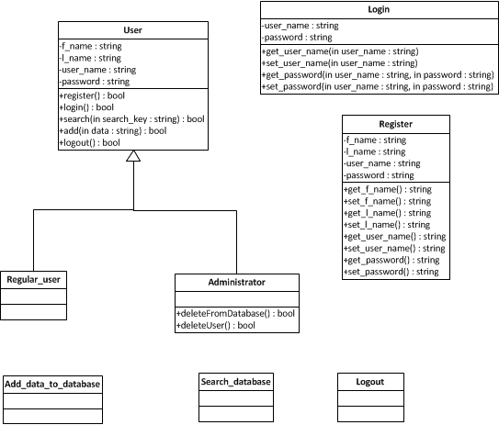

## Navigation Diagram

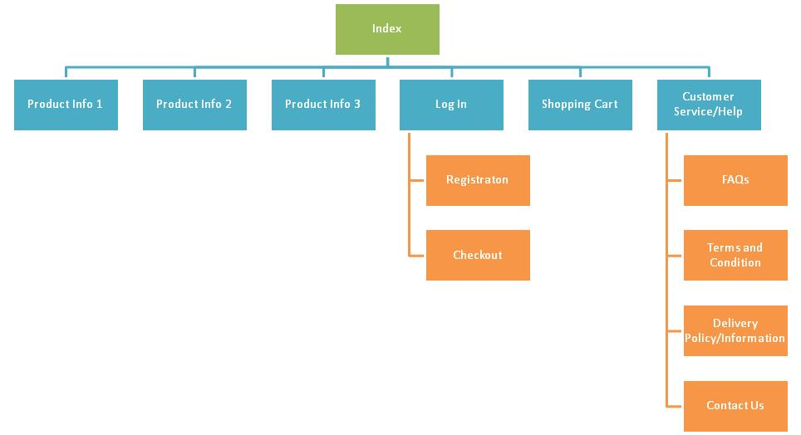

## Code Structure

### Database Controller Class

The class shown below is the ‘db_controller’ class which is the entire ‘db_controller.py’ module which can also be seen in section 10.12.

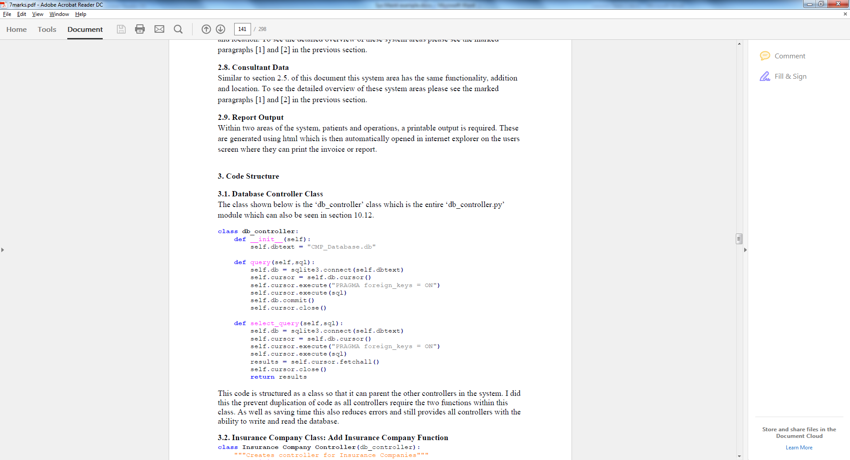

This code is structured as a class so that it can parent the other controllers in the system. I did this the prevent duplication of code as all controllers require the two functions within this class. As well as saving time this also reduces errors and still provides all controllers with the ability to write and read the database.

### (another subheading for all other classes)

# Variable listing

*Put a list here of all variables in your program. It should be structured as follows:*

In my code, I have used an underscore to denote private member variables. Python does not support public/private class variables so I have used this notation to show that a variable should not be used outside of the class where it is declared.

CustomerWindow

|  |  |
| --- | --- |
| **Variable name** | **Purpose** |
| self._btnLogin | Provides a button for the user to press after username/password have been entered |
| self._tableCustomers | TableViewWidget for displaying all customer information |
| row | Local variable. Integer for the row when populating the self._tableCustomers while iterating through the Customer table |
| Etc. | Etc. |

OtherClass

|  |  |
| --- | --- |
| **Variable name** | **Purpose** |
| Other variable | Other purpose |

# Explanation of detailed algorithms

*For any complex pieces of code which might be difficult to maintain in the future, put details here of how they work and why you’ve programmed it that way. Use technical language.*

## Database Window

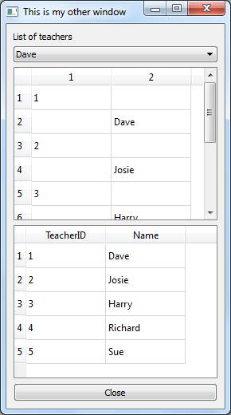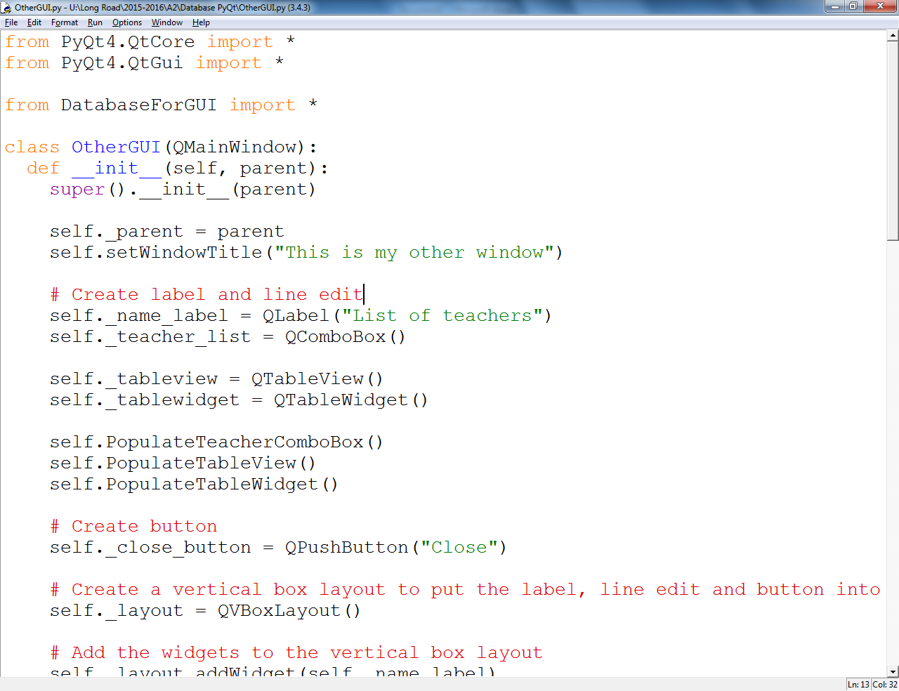

In this code I have used a TableView for the list of teachers whereas I used a TableWidget for the list of students. Using a TableView allows me to use Python’s built in Data Model functionality[1] which is useful in the Teacher list as it’s likely to be modified in multiple places.

I could have used a TableWidget in both places which would have simplified the process a bit, but wanted to make the data for teachers more modular, hence the TableView instead.

1. https://docs.python.org/3.4/reference/datamodel.html